**Project Report**

on

**Environment Relaxation**

**Submitted By**

Dweeti Bhavsar – 22000707

**Academic Year 2024-25**

**SYBCA (SEM V )**

**Submitted To:**

Mr. Darshan Parmar



* **Project Overview**

In My Project Environment Relaxation VR". It is a project to create an immersive experience of relaxing through virtual reality. In this project, they seek to create an environment that contributes towards relaxation and mental well-being by allowing the user to explore those serene landscapes combined with soothing background sounds.

* **Concept:**

In the Environment Relaxation VR experience, users can select from a variety of terrains—whether it's a quiet forest, a old sea port. As they "walk" through their chosen terrain, the VR environment immerses them with realistic visuals and gentle background sounds tailored to each setting. The visual and auditory stimuli work together to help users unwind, reduce stress, and enjoy a sense of calm.

* **Packages Used:**

1. Audio Toolkit:

The purpose is to control audio playback for the use in virtual reality, so that ambient sound can easily be harmoniously timed and coordinated with visual elements.

1. Nature & Environment Asset Packs (Unity Asset Store):

Pre-built assets like trees, rocks, water bodies, and other natural elements.

1. AR Foundation:

This toolkit lets the game interact with the player’s

Environment through AR. It makes it possible to detect surfaces and add AR features that work on both iOS and Android.

* **Steps:**

1. Set Up Unity and Project Settings
2. Import Required Assets
3. We have used different scripts for changing the scenes
4. Add the Assets through new scenes
5. Set up the XR Origin and align the Camera
6. Add Background Soundscapes

* **Model References:**

All the assets are downloaded from Assets Store.

* **Demo Images:**

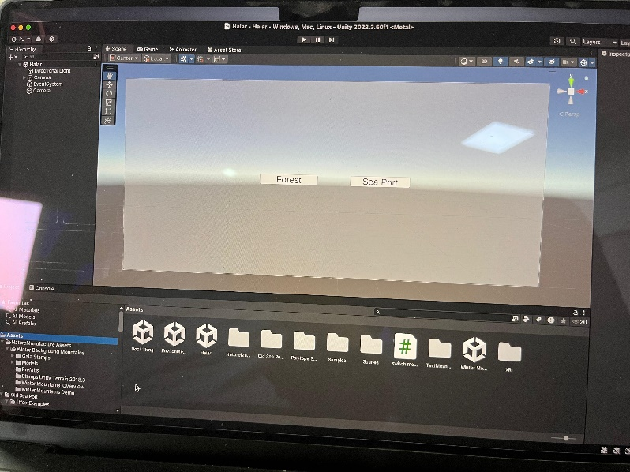In this image it shows that you get to choose your terrain in which you want to experience relaxation.

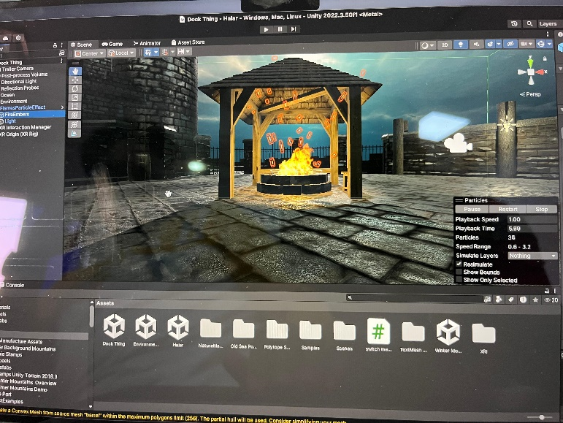This is old Sea Port where you can feel Midnight sea shore peace and roam around the area.

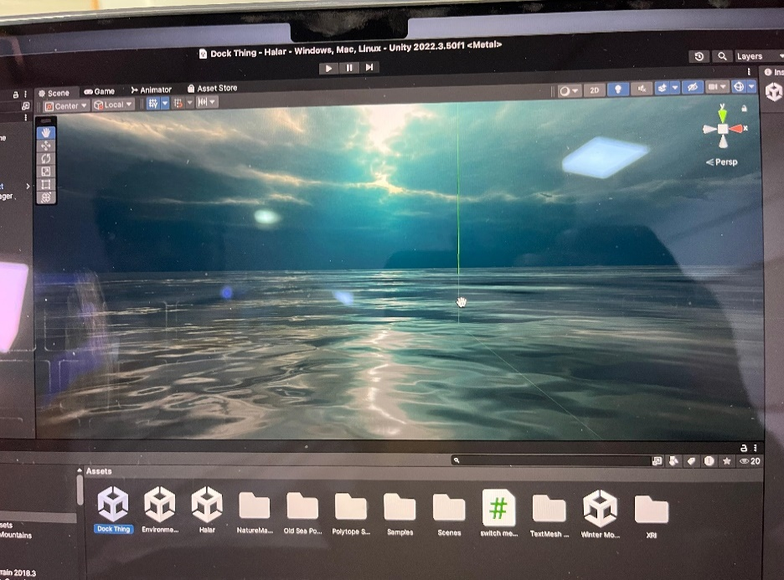

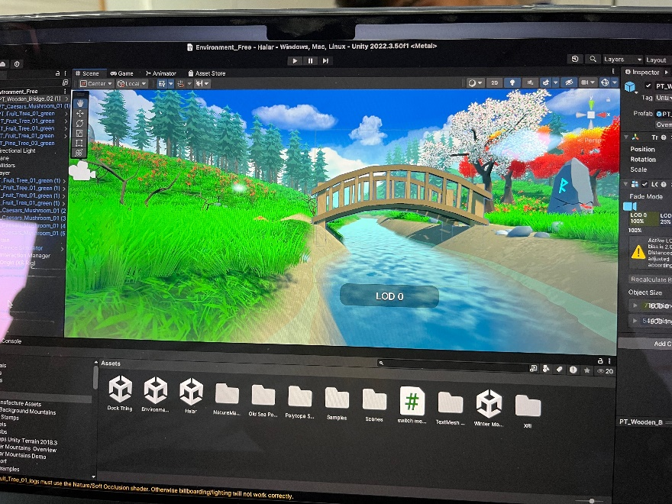This terrain is of forest area where you can feel nature and soothing sound of nature.

* **Plagiarism Report**

